Setup Jenkins pipeline and configure docker cloud in that.

Let's install Jenkins

_______________________________________________

>sudo apt-get update

>sudo apt install ca-certificates

install JDK to work with jenkins

>sudo apt-get update

>sudo apt- install default-jdk

it will ask you do you want install it then say y and press enter

>curl -fsSL https://pkg.jenkins.io/debian-stable/jenkins.io.key | sudo tee \

/usr/share/keyrings/jenkins-keyring.asc > /dev/null

>echo deb [signed-by=/usr/share/keyrings/jenkins-keyring.asc] \

https://pkg.jenkins.io/debian-stable binary/ | sudo tee \

/etc/apt/sources.list.d/jenkins.list > /dev/null

>sudo apt-get update

>sudo apt-get install jenkins

let's start jenkins

>sudo systemctl start jenkins

check the status of jenkins

>sudo systemctl status jenkins

press ctrl c and exit from status

let's copy the password for jenkins installation

>sudo cat /var/lib/jenkins/secrets/initialAdminPassword

you will get the initial password

copy that now open your master desktop

open browser type localhost:8080

it will ask your to enter password so enter copied password and then press enter

click on install suggested plugins.

it will give you screen for creating a user so enter your details username,password,email,full name

remember your username and password.

click and save and continue again you will get the url screen there also save and continue and now you will get the message jenkins is ready.

Let's Install Docker plugin in jenkins.

click on manage jenkins> manage plugins> available plugins > search for docker >tick on Docker plugin scroll down and click on install without restart.

once this is installed.

let's configure docker cloud.

>mange jenkins> manage nodes and clouds> configure cloud> add a new cloud> select Docker>

by default the entered name is docker keep it as it is then click on docker cloud details and enter Host URI

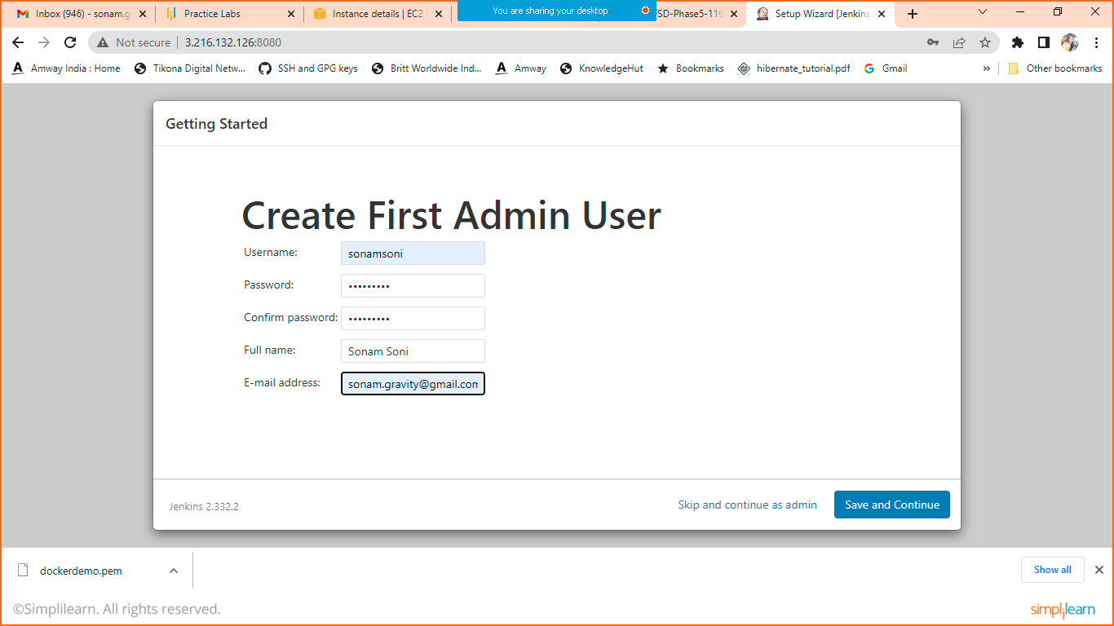

Enter details and click on save and continue

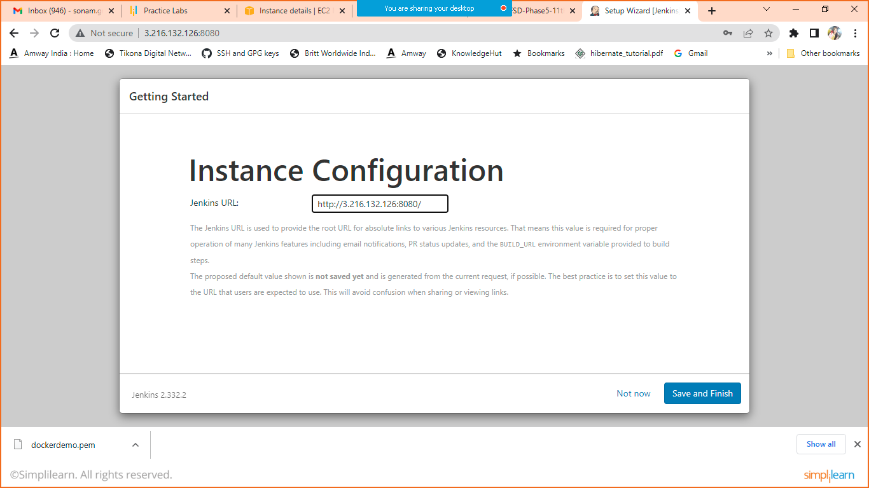

Click on save and Finish

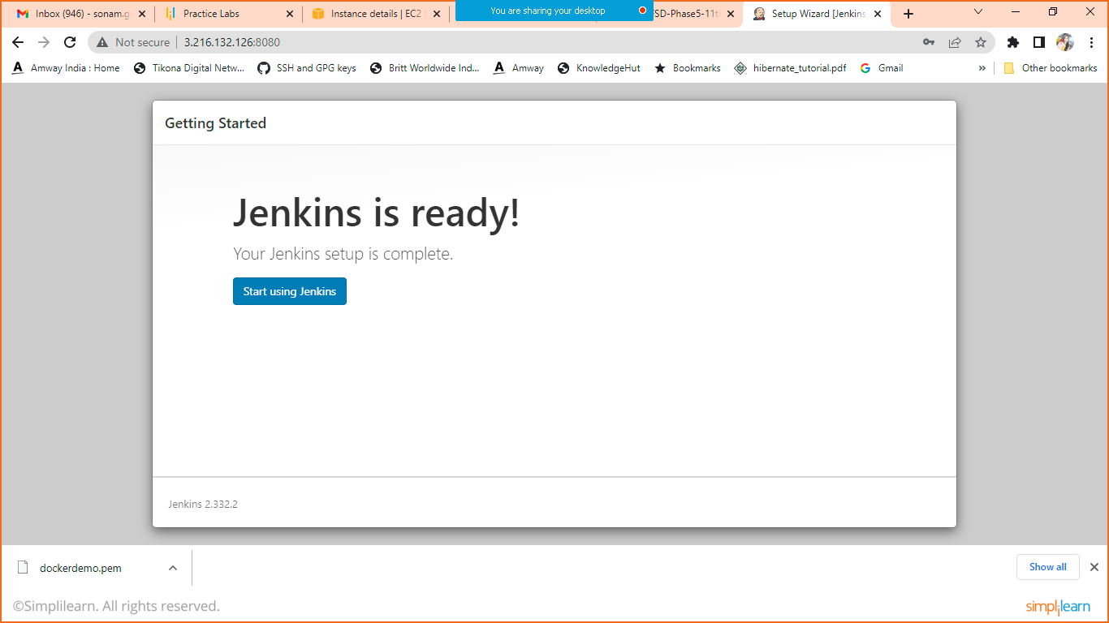

Click on start using Jenkins

This is your Jenkins Dashboard

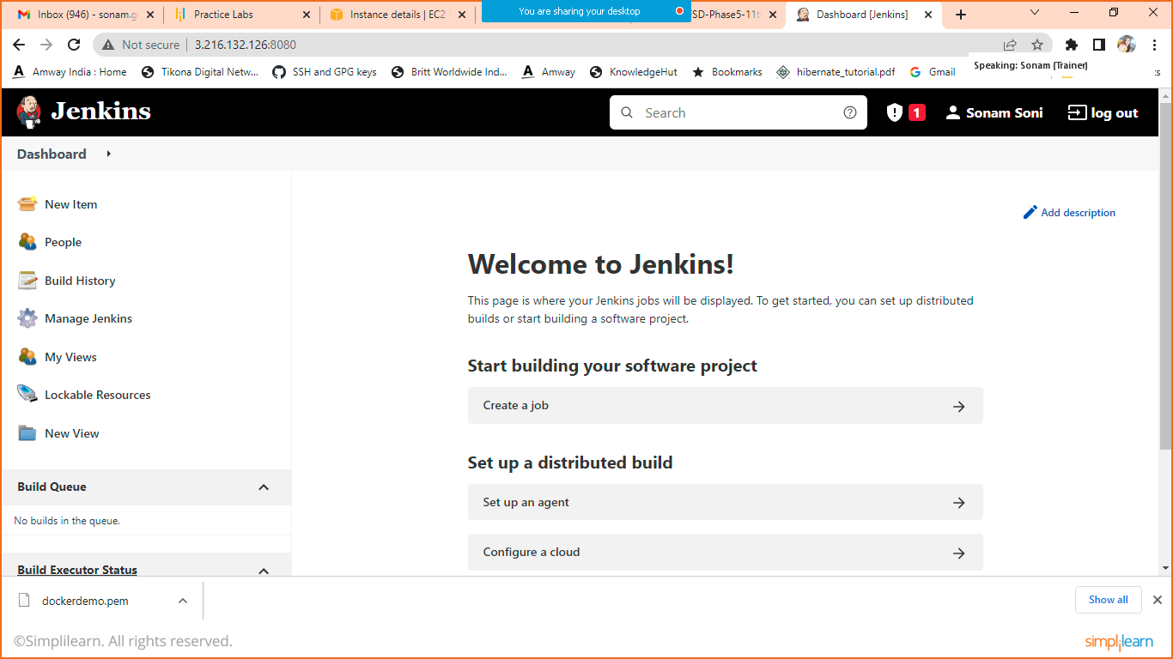

1. Install docker Plugin

Click on manageJenkins > manage plugins > available >search for docker plugin

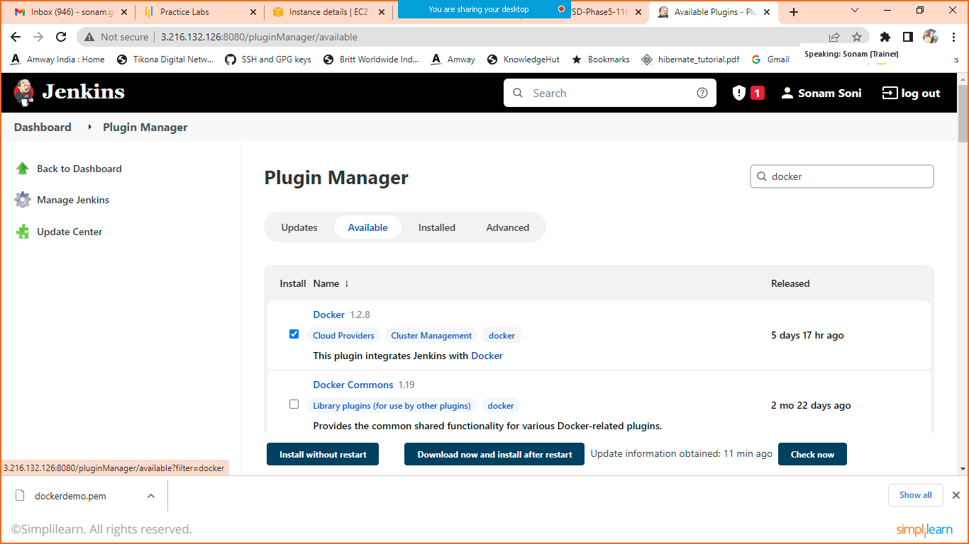

Select Docker and install without restart.

Go back

1. Configure docker cloud in Jenkins

Click on manageJenkins > click on manage nodes and cloud > click on configure cloud (left hand side)

Click on add new cloud > select docker

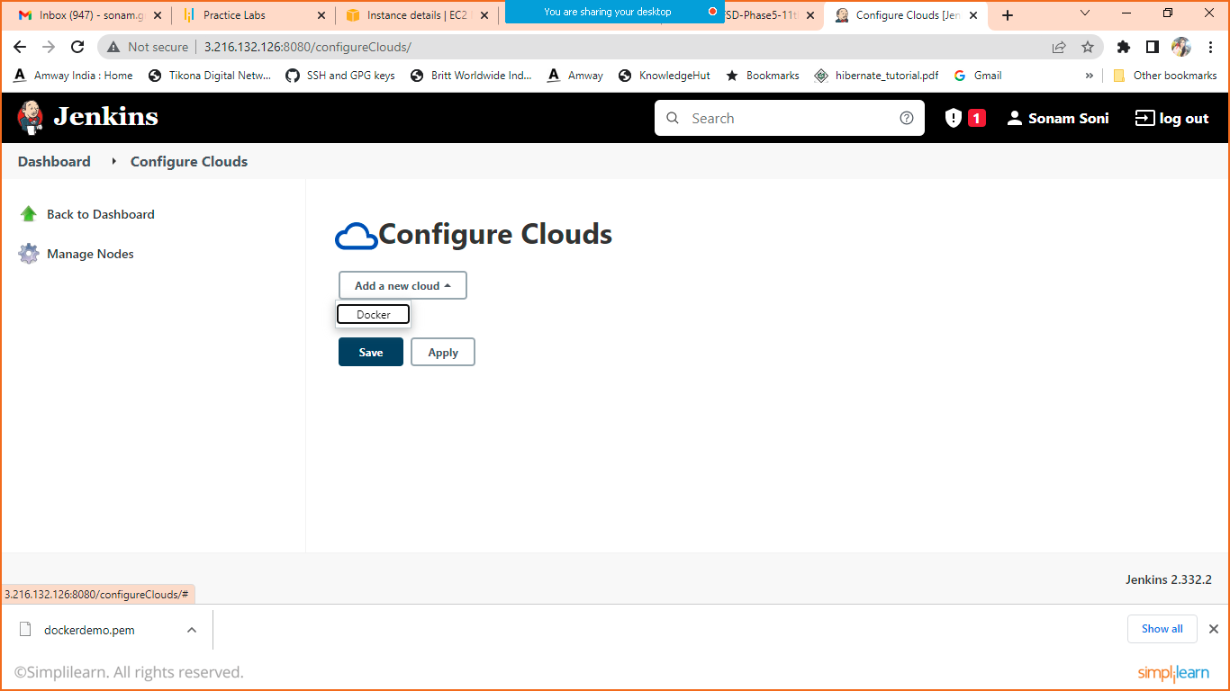

When you click on docker you will get below mentioned screen.

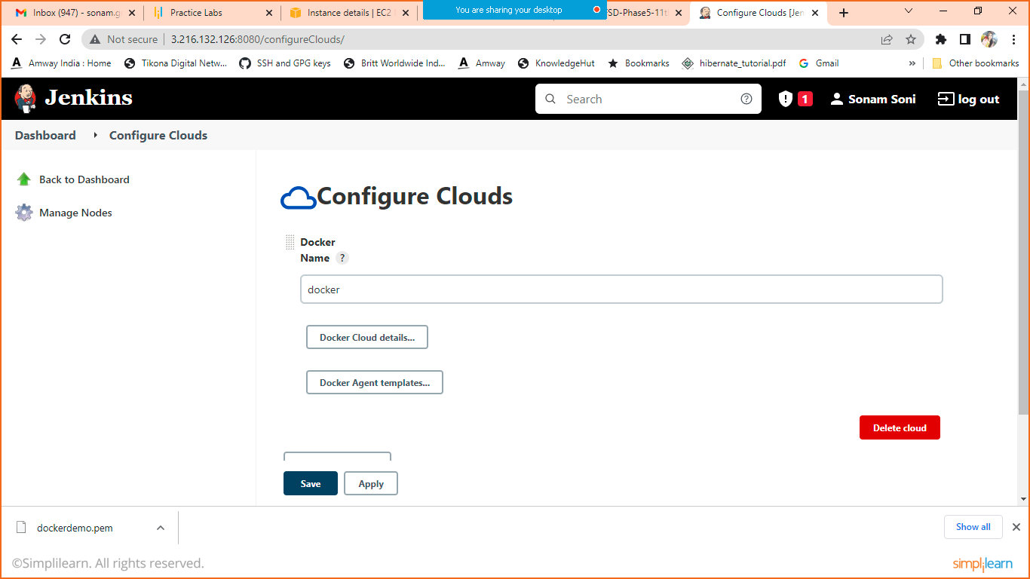

Click on docker cloud details and enter HostURI

unix:///var/run/docker.sock

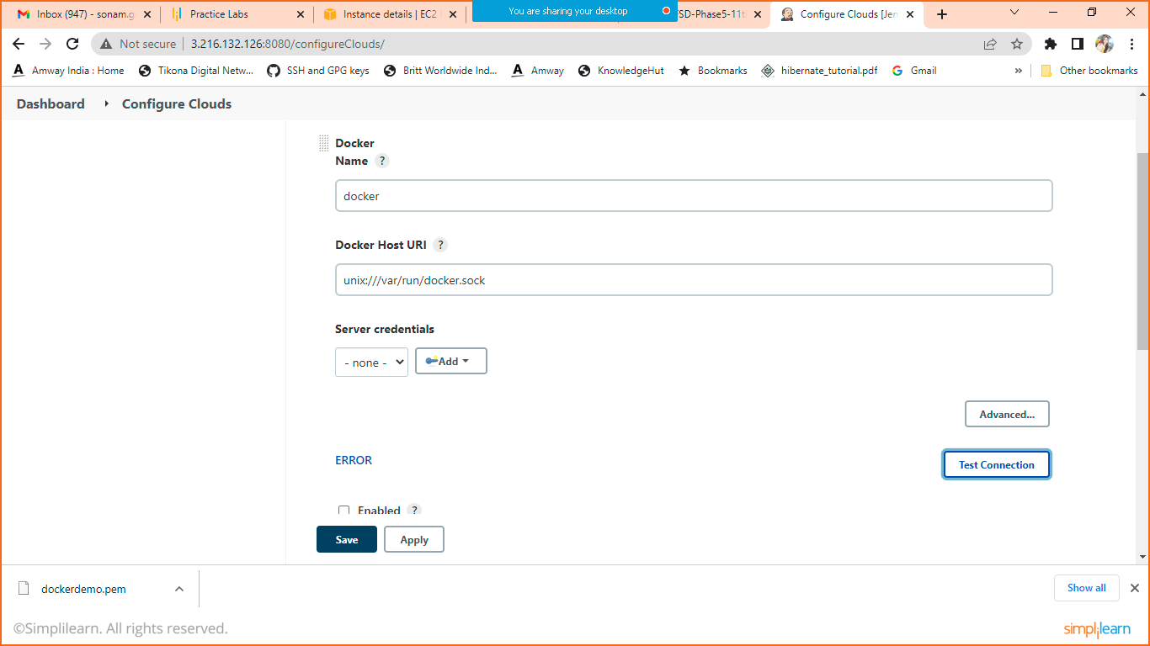

Click on test connection and check are you getting connection or Error

If error then go to your cli and execute below mentioned command.

sudo chmod 777 /var/run/docker.sock

refresh then check again.

1. Create Pipeline
2. Click on new item > project name(Jenkinspipeline) > freestyle Project> OK
3. Give description

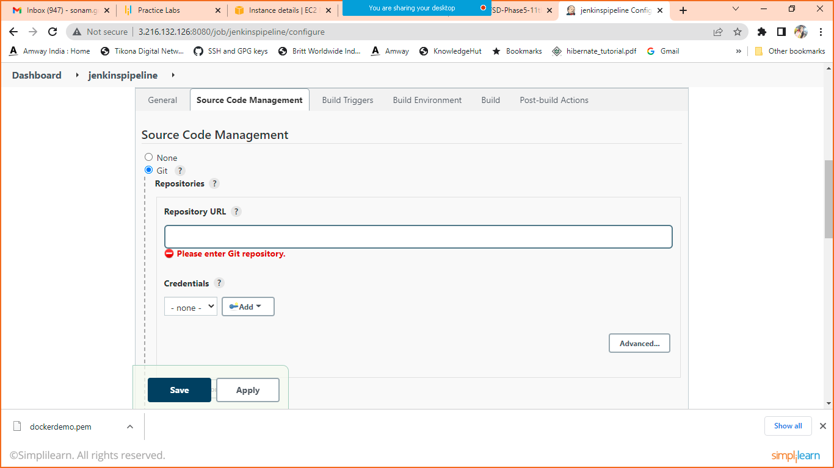

Enter Git URL

Change branch name

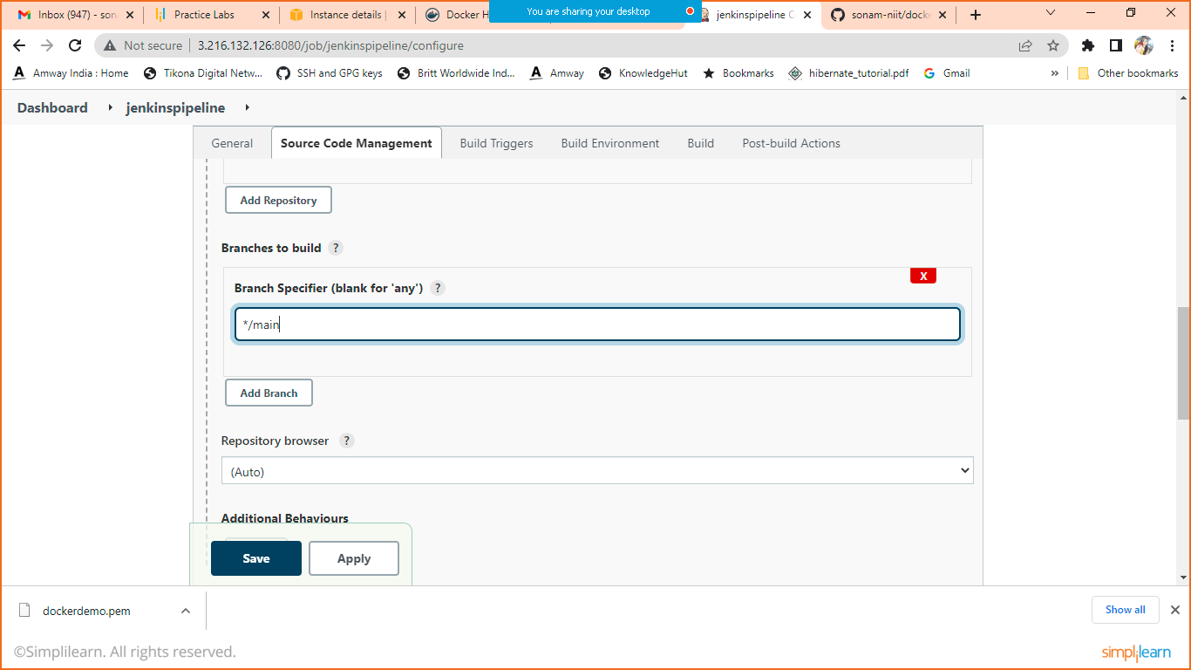

Schedule the build using Poll HCM

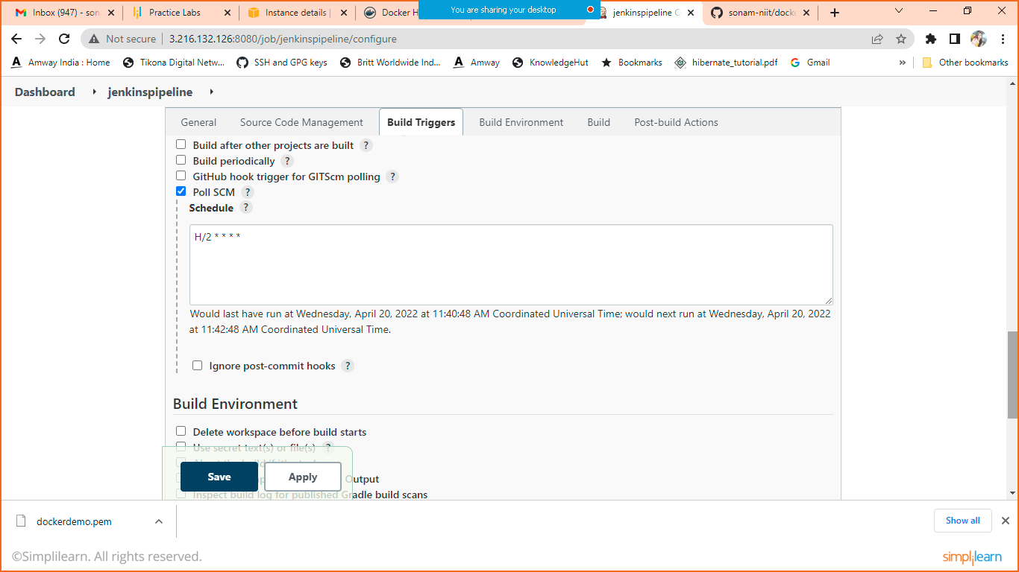

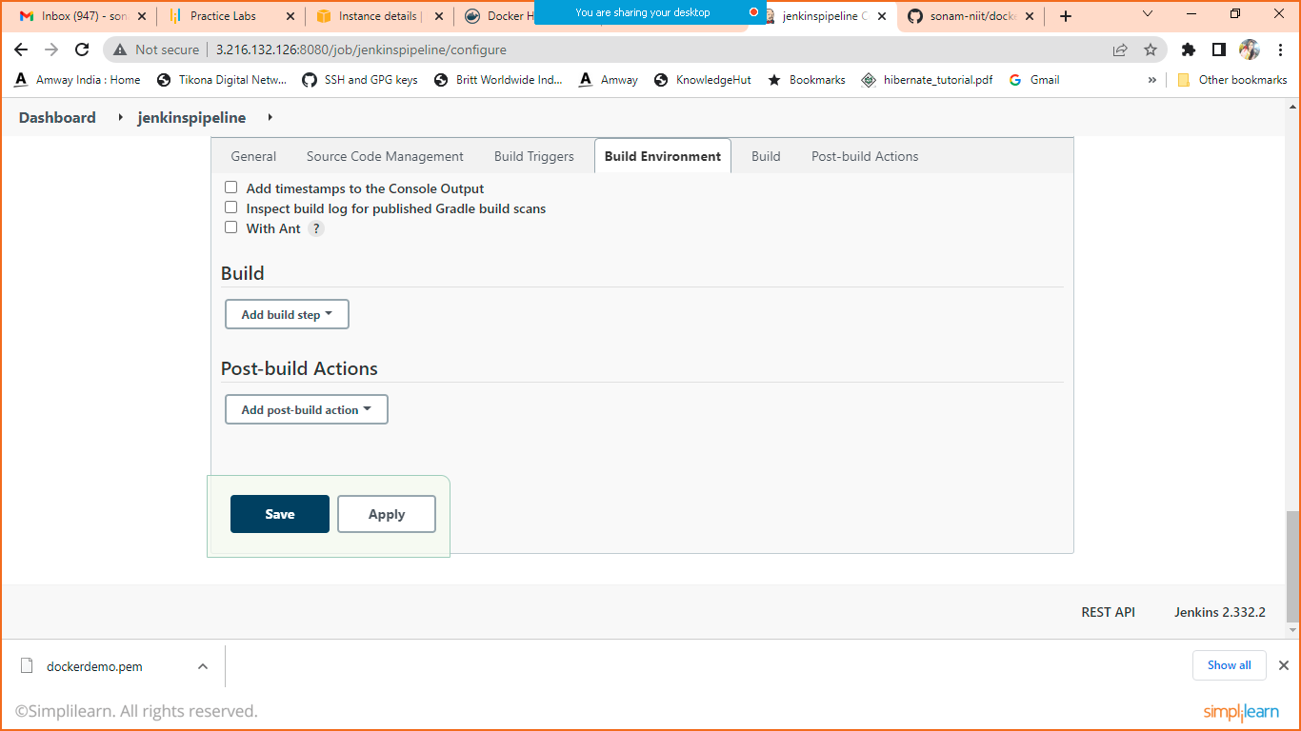

Click on Add Build Step

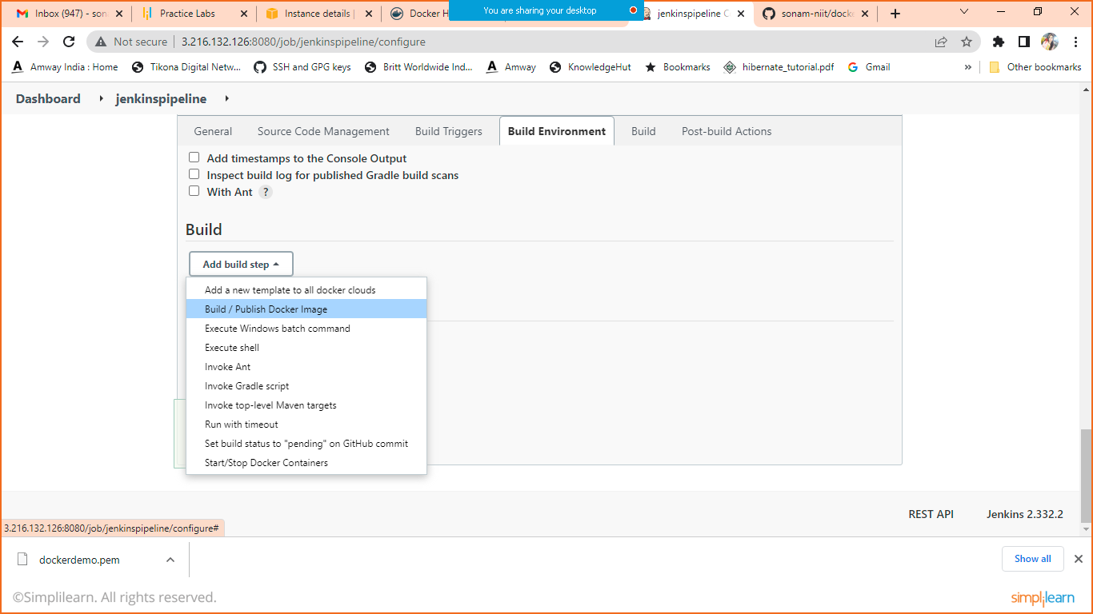

Click on build and publish docker image.

Keep directory for docker file blank as we have dockerfile in root folder only

In cloud

Select docker

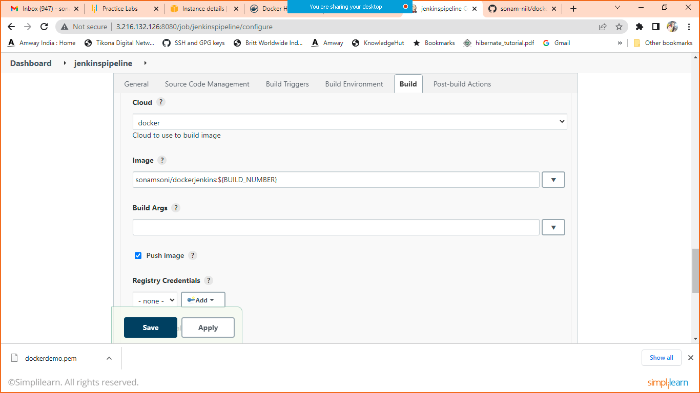

Give the image name and click on push image too.

Click on Add to add registry credentials

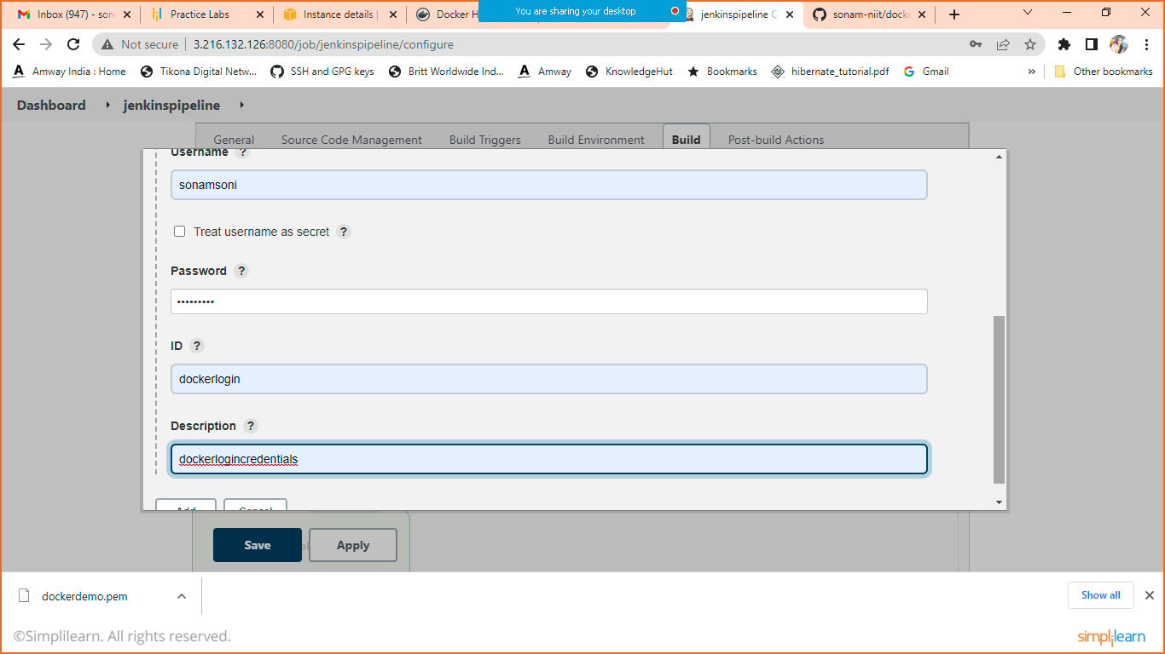

Give your docker hub credentials

Select created login from registry credentials

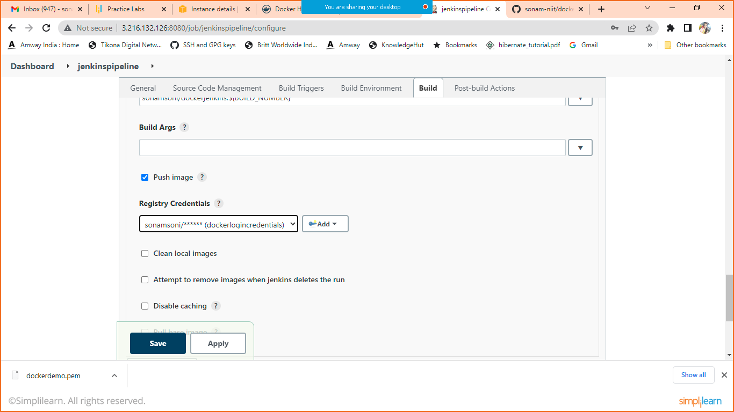

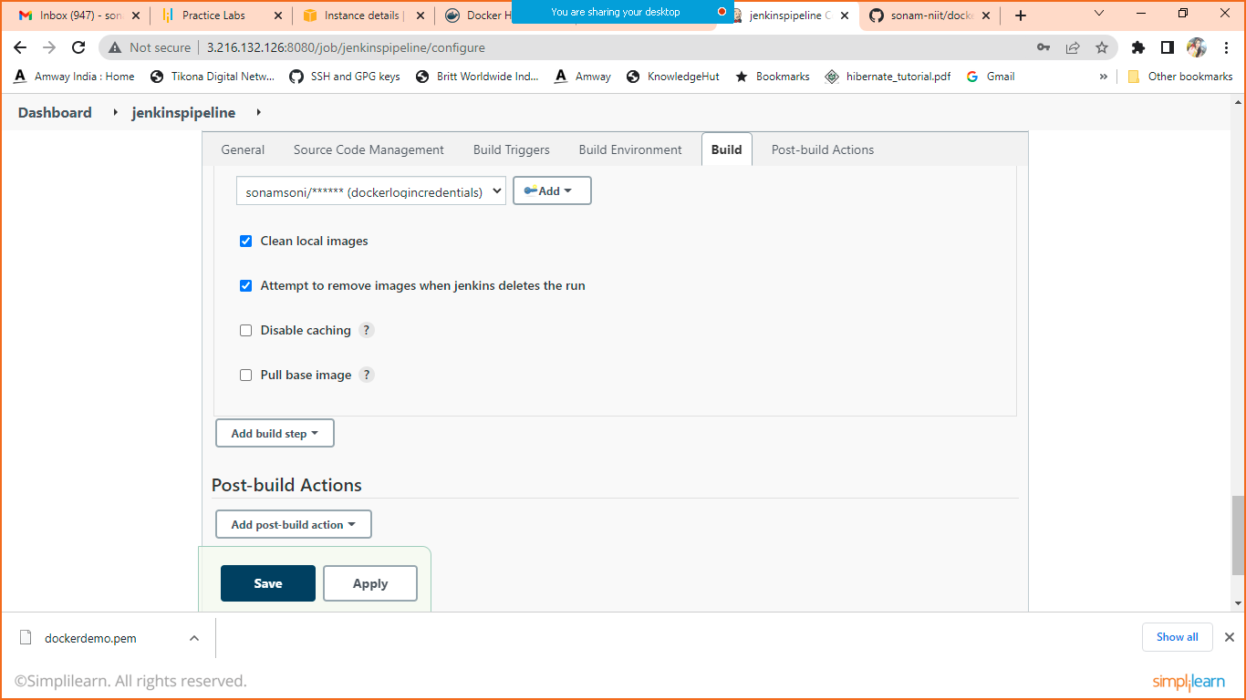

Apply and Save.